ANARKALI MEAUREMENT FORM

Frontsize:-
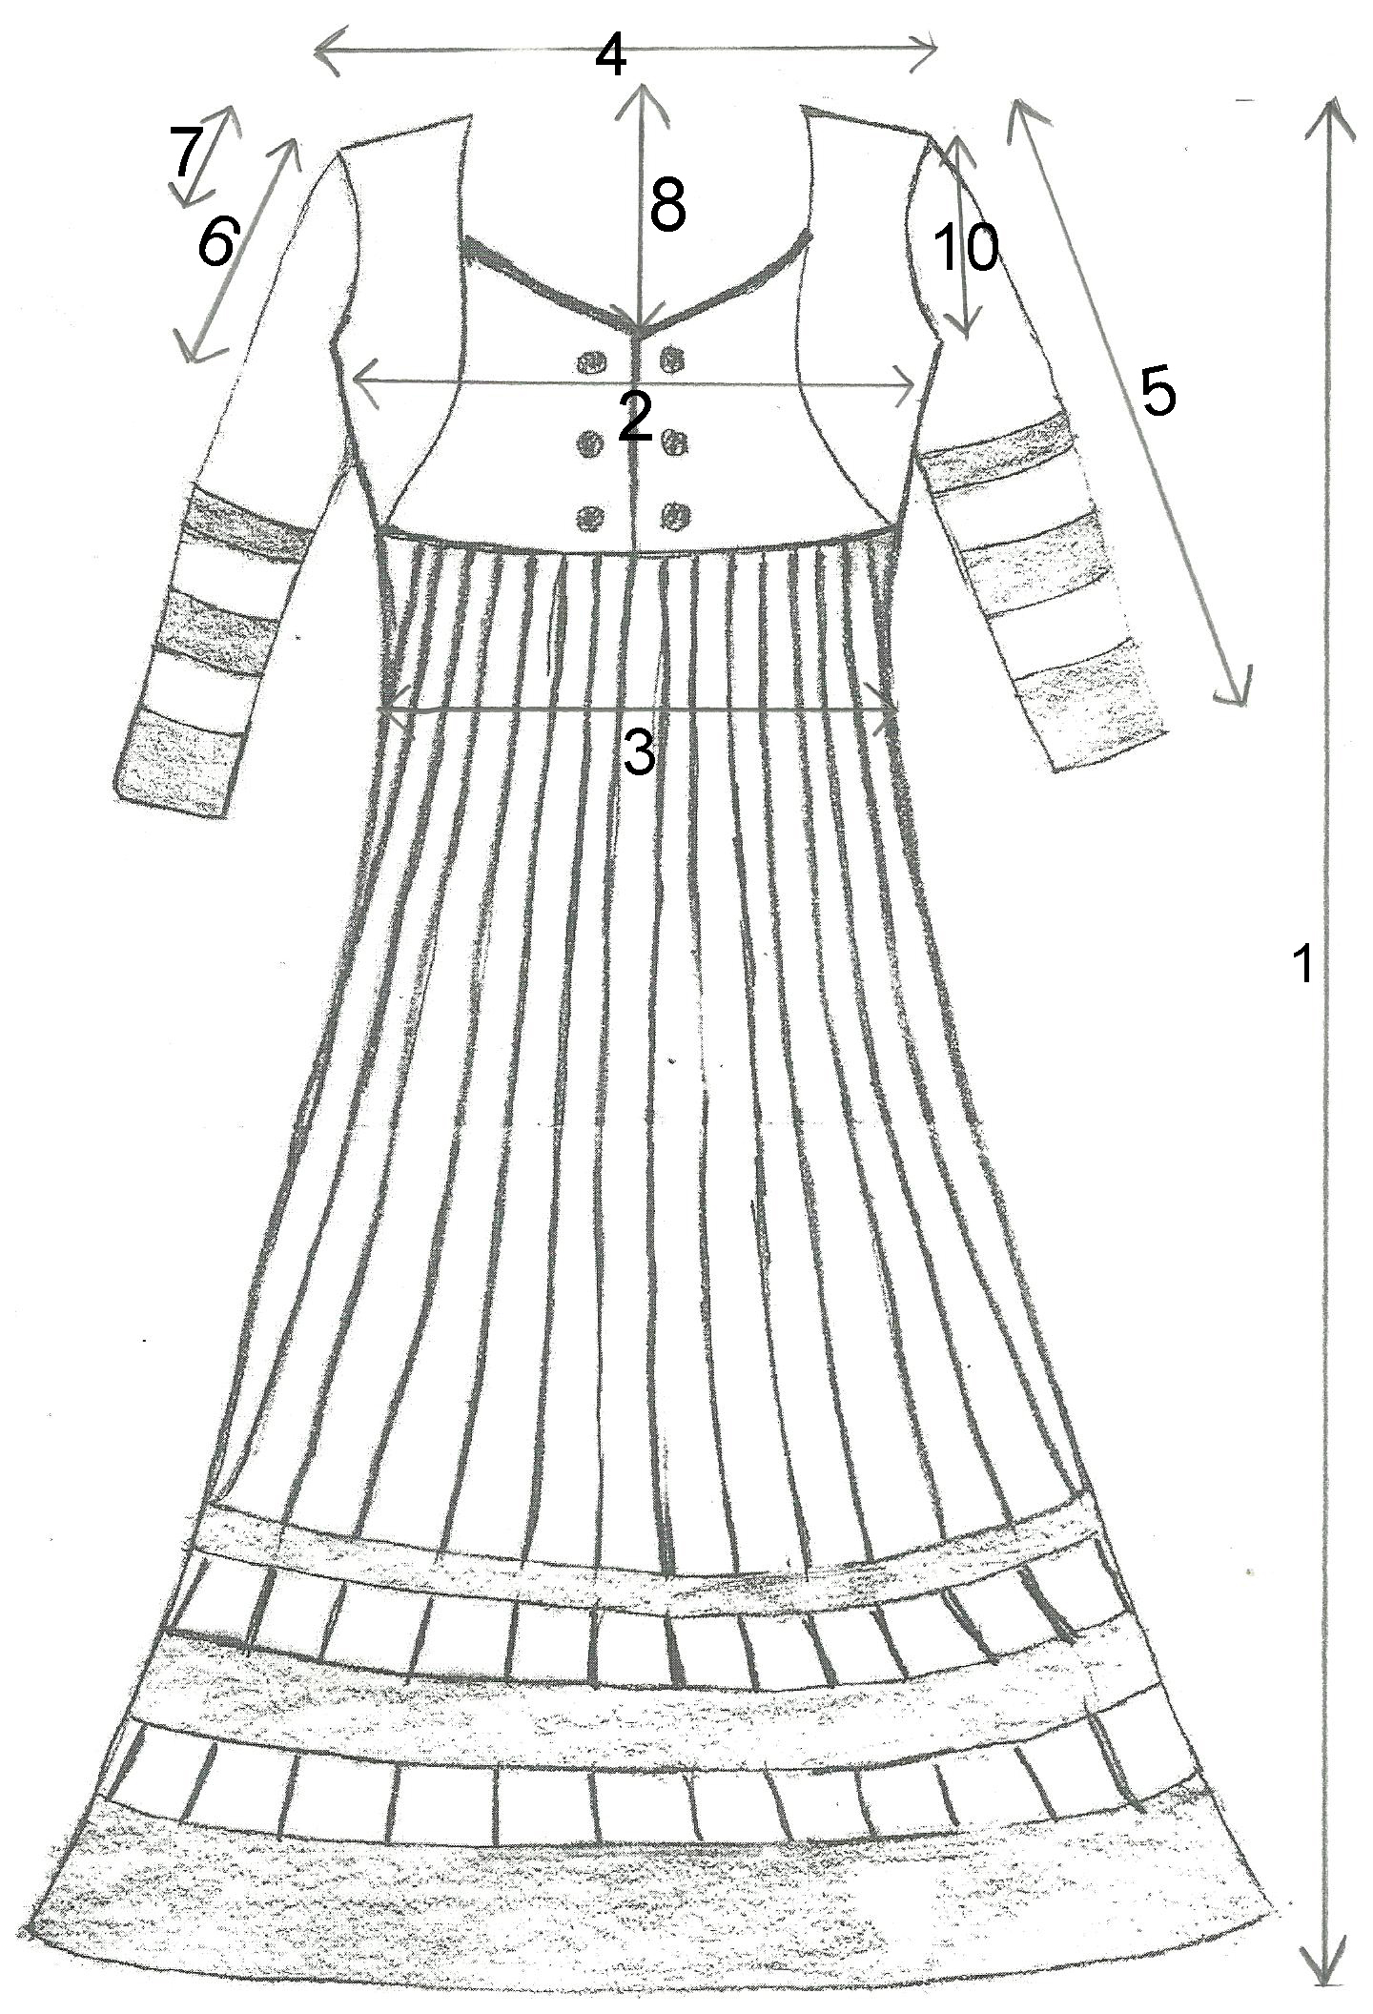

Backside:-
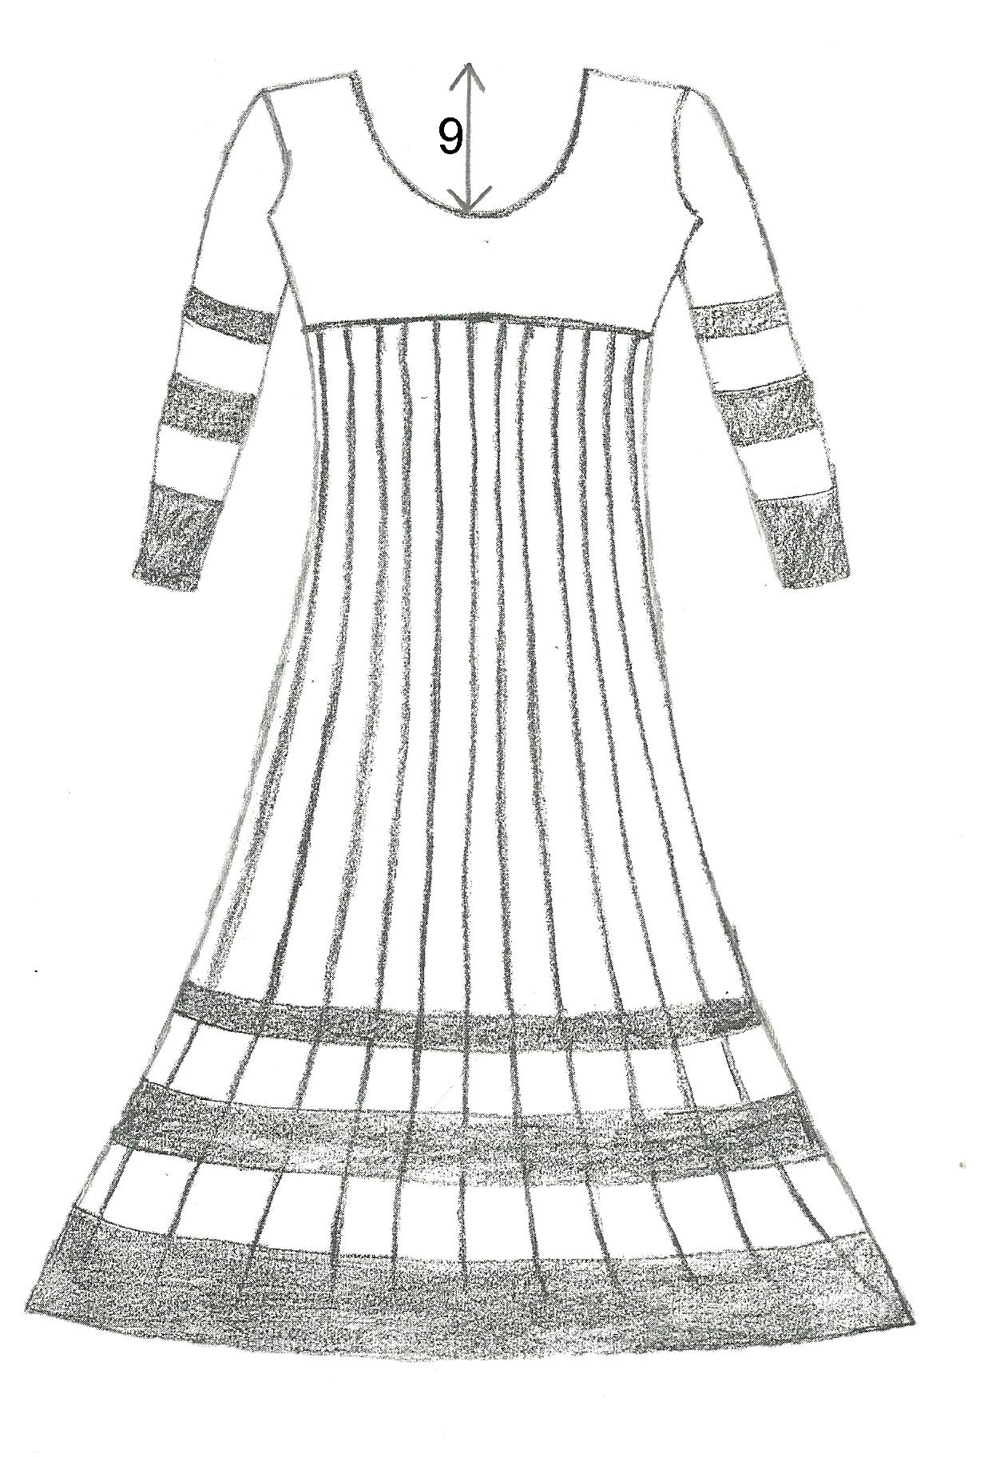

Meaurements :

1-Leangth : 52 inches

2-Chest : 38 inches

3-Waist : 32 inches

4-Shoulder : 15 inches

5-Full Sleevees : 22 inches

6-Half Sleevees : 5.5 inches

7-Cap Sleeves : 3.5 inches

8-Front Neck Deep : 7 inches

9-Back Neck Deep : 9 inches

10-Arm Hole Round : 16 inches

Note: lease take special care while submitting your measurement as we will not be responsible for incorrect measurement submitted by you.

Kindly send in the filled in form to mailto:info@singhanias.in?subject=Anarkali Suit Measurement along with your order number in the subject line.

